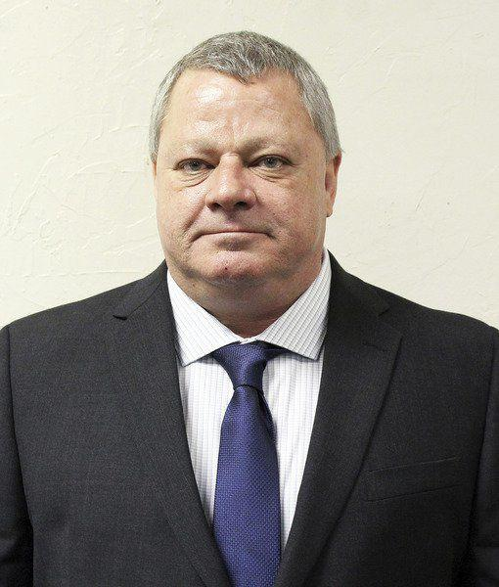
Parker County resident Gregory Scott Gates, 54, has filed to run for sheriff to help save the taxpayers' money.

Gates, a Republican, filed on Nov. 29 and has lived in the county most of his life and has owned several businesses, most recently Aces Wrecker Service.

“I went into the wrecker business and got on with the sheriff’s department and police department, so I’ve been active with that. I’ve owned Lone Star Homes for many years, I’ve got some rent houses that I have elderly people in and most of them don’t pay over $200 to $400 a month. I’ve always been a working guy,” Gates said. “I just felt a calling and I’ve always wanted to be in law enforcement. My brother is a U.S. Marshal and has 17 years in that and 10 years in the Army.”

Gates said the No. 1 reason he’s running for sheriff is to help save the taxpayers money by making some changes with the jail and personnel.

“I feel there should only be one officer at [the auto registration office] and the other three that are sitting there I feel that’s a waste of money, they need to be behind the booking facility at the sheriff’s office. The older we get, the more we depend on people and I feel they need one trained, healthy deputy that can actually take care of the three jobs that are there,” Gates said. “Another thing is, I am totally against LaSalle [Corrections] running the jail. Our jail has 445 beds and they bring in federal prisoners, they bring in prisoners from other counties, to be in those beds. I feel that that’s not right. I think that it’s a farce that our sheriff’s office does not run our jail. I do not feel that it should be a for-profit entity to bring in an out-of-state company to pack our jails for their profit. I think Parker County should be for our residents, I don’t think they need to bring in federal prisoners.”

Gates said in having the sheriff’s office run the jail, he would have fewer employees running the jail, but employees that are highly trained to do so.

“When you have 445 people that you’ve got to watch, well you’re going to have to have a lot more jailers, correctional officers. One good trained deputy can do what five untrained off-the-street people can do,” Gates said. “I don’t want our money from our jail going to Louisiana to pay their guys $10-$15 an hour that are untrained for up to one year. They work in that jail up to one year with no training at all. When you’ve got that many people in there, you could have two trained deputies and even paying them $50 an hour you’re still going to drop that money. We could drop the inexperienced jailers and I think Parker County should be taking care of Parker County.”

Gates said if he couldn’t turn the jail around within one year, he would donate his check to a good cause.

“I know I can turn it around and make it where it’s paying for itself,” Gates said. “I know how to make a dollar stretch and I know how to make money. It’s a lot easier to spend money when you don’t have the sweat in it.”

Gates said another platform he’s running on is to help keep the children in Parker County off drugs.

“My emphasis will be on trying to keep our children away from drugs and one of my best ideas is that I want to have a floating counselor to go throughout the county to the high schools to speak to kids about the drug problem. I can’t put a counselor in every school, of course, so I would want a floating person,” Gates said. “I’ve been active in Child Protective Services for about 11 and a half years, we had five foster kids and adopted two of them.”

Gates said he doesn’t want to talk bad about anyone, but that he feels it’s just time for current Sheriff Larry Fowler to retire.

“I’m not here to run anybody down or talk against anybody, I think everyone has their own platform to run on,” Gates said.

Fowler has filed to run for another term as sheriff.

“When I took office the needs of this sheriff’s office were obvious. It was quite a challenge to get where we are today and to be quite honest about it, I want another term because I want to enjoy this,” Fowler said in a previous interview. “We’ve had great success and that may sound a little simplistic, but it’s the truth and I’m at a point now where I’m enjoying what we’ve accomplished.”

